This assignment uses a GCU-provided virtual machine that will be specified by your instructor.
Metasploit comes with various preconfigured backdoors and payloads both for Windows and Linux operating systems. These backdoors can be used to exploit flaws discovered in the source code of a host. Metasploit also comes with an additional tool set that allows the security practitioner to create custom backdoors (payloads) to be delivered by Metasploit. These custom payloads can be used to evade Anti-Virus (AV) protection and established trust relationships between information systems.
- Using the GCU-provided virtual machine and MSFVenom (MSFPayload + MSFEncode), available in Metasploit Framework, found in Kali Linux, create a custom payload and install that payload as a backdoor in an exploited host and establish a remote access connection verses a local login.
- Document your findings under Phase Testing in the "ITT-340 PEN Testing Report Guidelines," located in Class Resources. Refer to "Writing a Penetration Testing Report," by the SANS Institute, located in Class Resources, for examples of PEN testing reports.
- Append this assignment to the PEN testing report and resubmit the report (Passive Corporate Recon + Automating Information RECON + NMap Scan + Vulnerability Assessment + Applied Exploitation using Metasploit + Custom Payload).

Downloaded the putty.exe
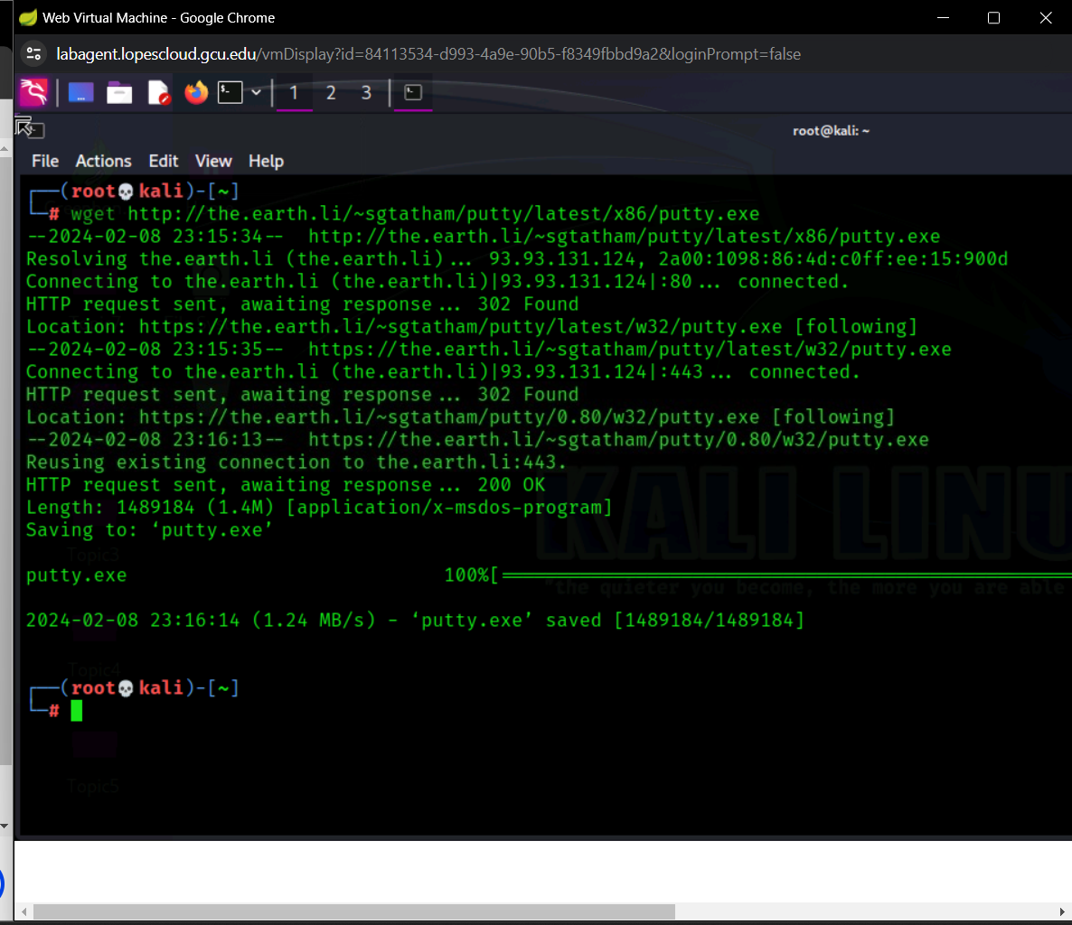
Then set a custom payload with a meterpreter reverse and backdoor to the windows vm: 127.0.0.1
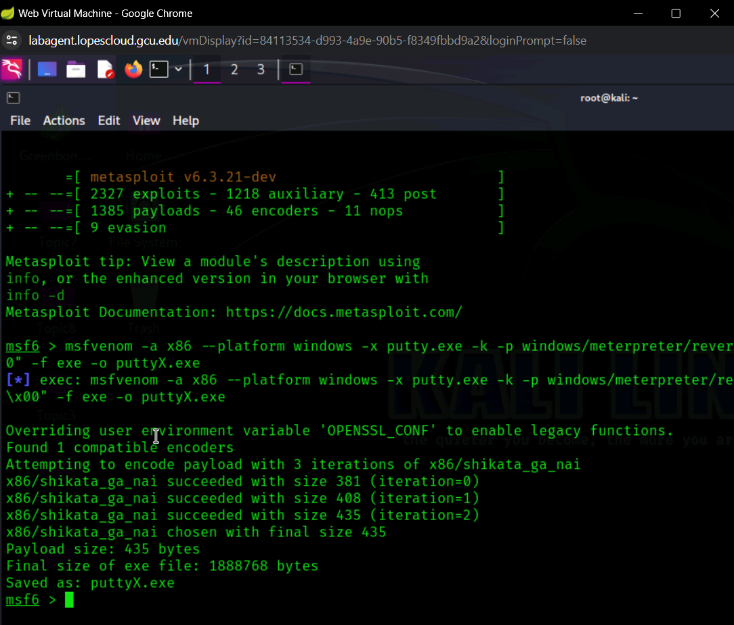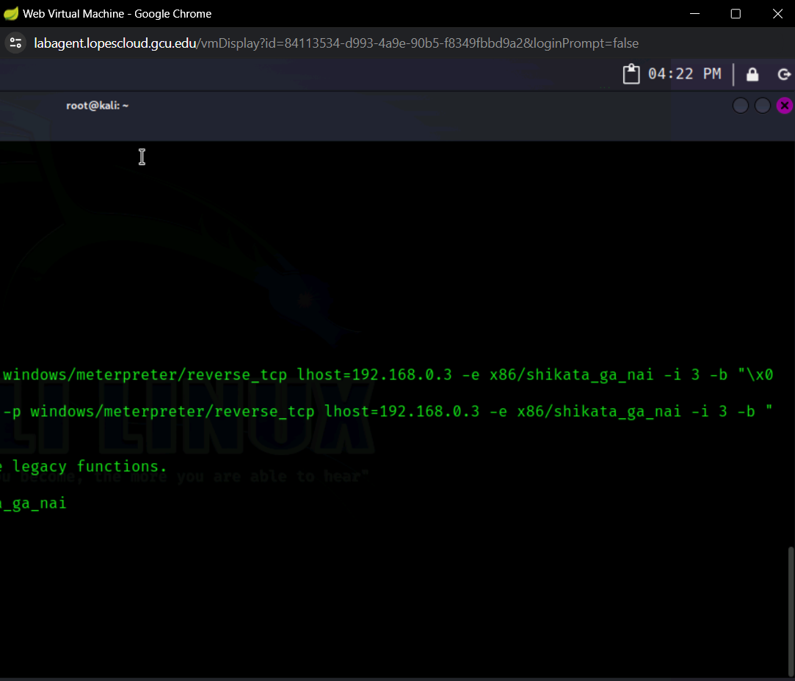
The putty executable file is not created but needs to be accessed by the windows vm: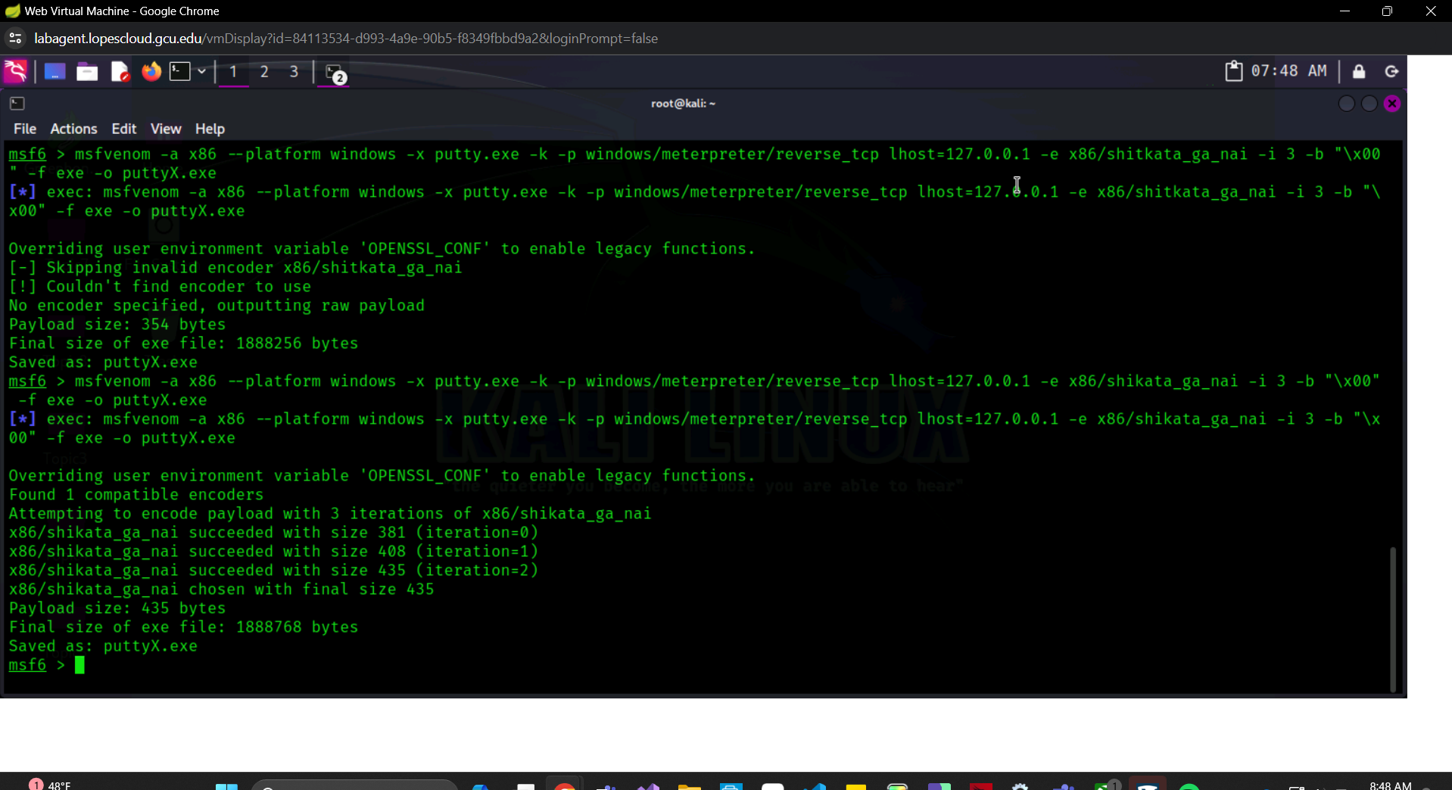

Created a directory called share and then checked to ensure that it did exist: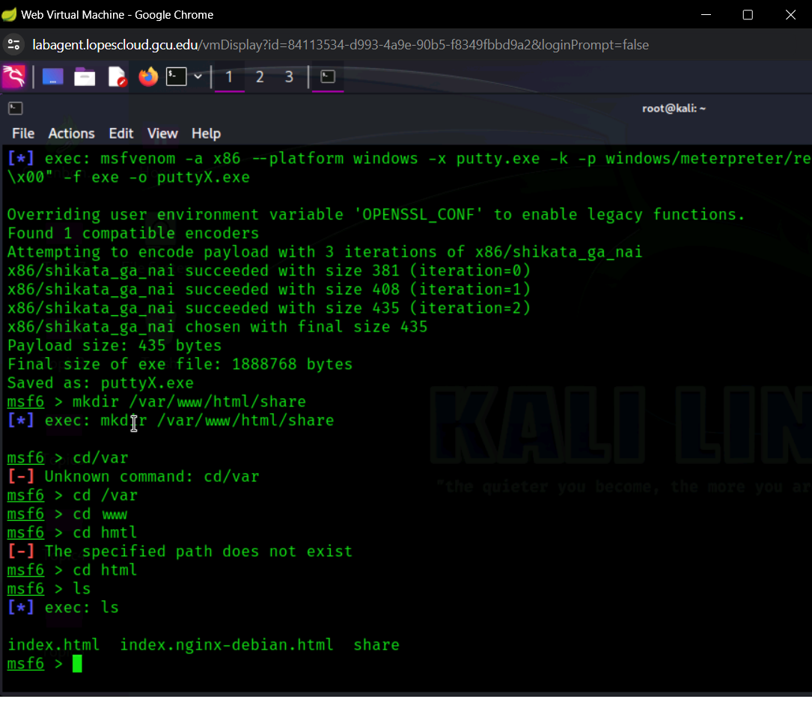

Realizing that i used the wrong ip address the first run I repeated all previous steps and had to use different file names. But was finally able to run the reverse tcp handler
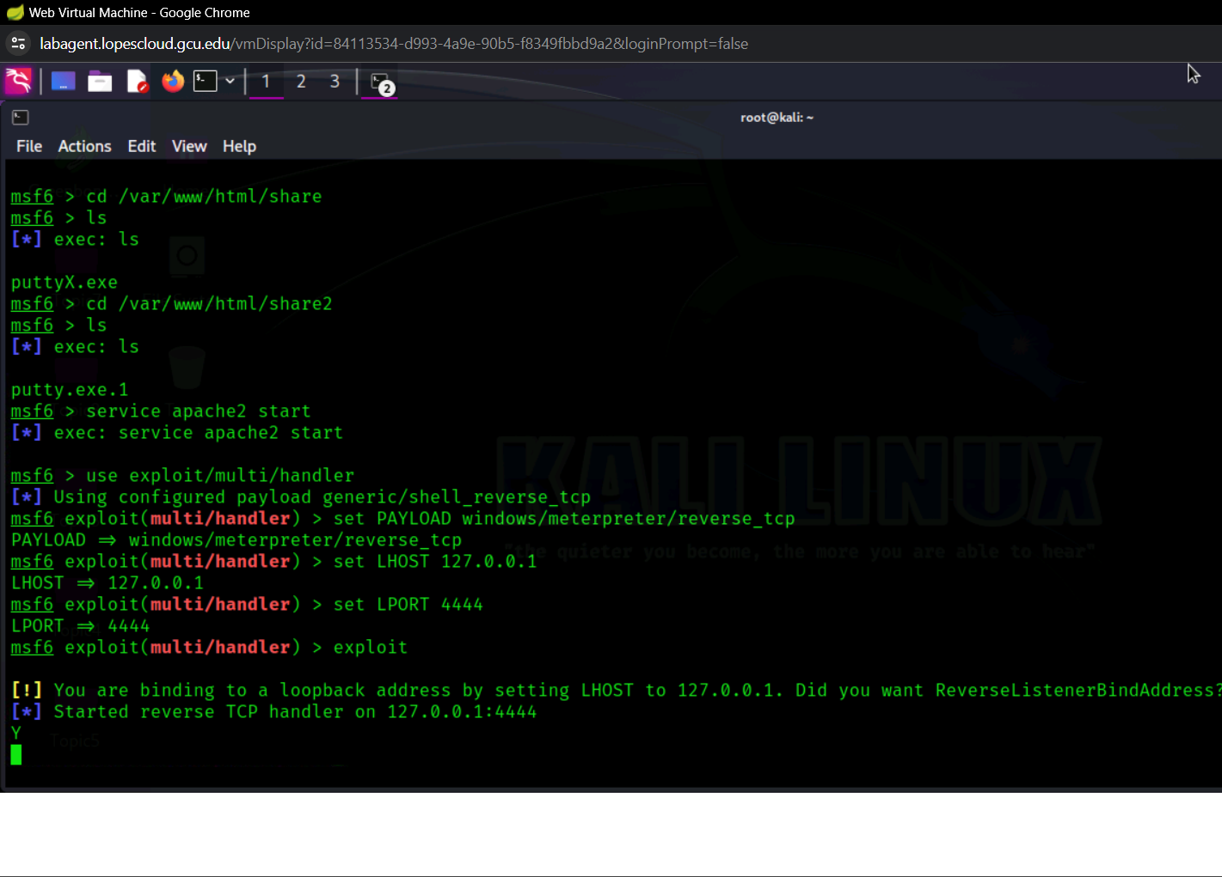
When trying to access the browser it said it was unable to connect but it could be because my host laptop was connected to a public wifi network or because I utilized the wrong port so I went back and changed the LPORT to 9392 but it caused the screen to become frozen.
